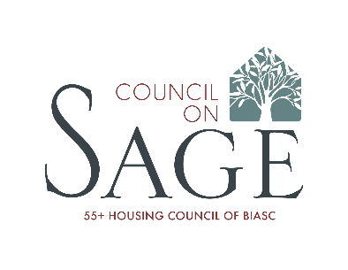

2021 Patron Benefits

Podium Patron ($2,000)
- Two (2) SAGE Awards dinner tickets
- Logo recognition in event presentation ("Brought to you by...")
- Company logo displayed 3 times during awards presentation
- Recognition on SAGE Awards event-night materials
- Acknowledgement on Councilonsage.com, SAGE social channels and Council newsletter through year end

Champagne Greeting Patron ($1,750)
- Company logo displayed 2 times during awards presentation
- Option to have logo on cocktail napkins during reception
- Recognition on SAGE Awards event-night materials
- Acknowledgement on Councilonsage.com, SAGE social channels and Council newsletter through year end

Awards Patron ($1,500)
- Company logo displayed 2 times during awards presentation
- Recognition on SAGE Awards event-night materials
- Acknowledgement on Councilonsage.com, SAGE social channels and Council newsletter through year end

Wine Patron ($1,250)
- Company logo displayed during awards presentation
- Ad in Ceremony Program
- Recognition on SAGE Awards event-night materials
- Acknowledgement on Councilonsage.com, SAGE social channels and Council newsletter through year end

Centerpiece Patron ($1,000)
- Company logo displayed during awards presentation
- Company logo on centerpiece inserts at awards
- Recognition on SAGE Awards event-night materials
- Acknowledgement on Councilonsage.com, SAGE social channels and Council newsletter through year end

Dessert Patron ($1,000)
- Company logo displayed during awards presentation
- Recognition at event during Salute to Underwriters
- Acknowledgement in event-night materials

Valet Patron ($750)
- Company logo displayed during awards presentation
- Recognition at event during Salute to Underwriters
- Acknowledgement in event-night materials

Event Patron ($500)
- Company logo displayed during awards presentation
- Recognition at event during Salute to Underwriters

Friends of SAGE ($250)
- Name displayed during awards presentation
- Recognition at event during Salute to Underwriters

For more information, please contact:
Lisa Meadows: lmeadows@biasc.org

